*The Arc of the St. Johns*

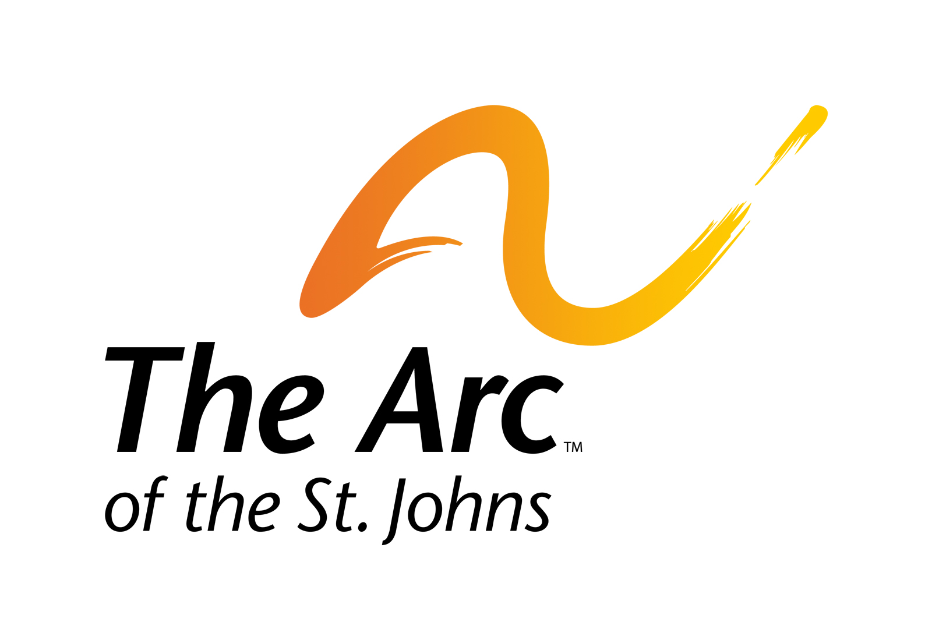

**Board of Directors Meeting**

**THERAPEUTIC LEARNING CENTER**

The A. D. Davis Building

3940 Lewis Speedway, St. Augustine, FL 32084

**November 16, 2023**

**THERAPEUTIC LEARNING CENTER FOR CHILDREN**

**Attending:** Board President Aaron Johnson, Board Vice President Mike Davis, Board Secretary Andy Norman, Directors Ron Brown, Brookes Burkhardt, Ann-Marie Butler. Absent: Treasurer Grant Misterly, Past President Rob Matthews, Chuck Gillingham, and Kevin Sweeny. **Also attending:** Executive Director Kathy Jackson, CFO Justin Breidenstein, and Development Director Neal Benson.

A quorum was announced and the meeting was called to order at 12:15 pm by Board President Aaron Johnson.

The minutes of the September 21, 2023 meeting of the charter school were reviewed and approved following a motion by Ron Brown and a second by Mike Davis.

Aaron Johnson recognized Todd Neville of Neville|Wainio, CPAs to present the annual financial audit of the school. The audit was received, reviewed and accepted following a motion by Ron Brown and a second by Andy Norman. (A copy of the audit is on file with the Director of Finance at The Arc of the St. Johns.)

Aaron opened for the floor for public comment. Hearing none, and there being no further business or comments, the meeting was adjourned at 12:30 pm.

Respectfully submitted, Neal Benson for Andy Norman, Board Secretary